Zeiss AxioObserver startup guide
last updated 20 Oct 2021
Shutdown This is a checklist. Make sure you do every step.
- BEFORE you quit Zen software, if you were using the incubator:
Turn it off from within Zen software (this is in the right panel).
Turn off CO2 tank or other gases used.
- Copy data to shared server space .
- Set lens to 10X
- Manually focus lens to lowest position.
- If you used an oil immersion lens, gently drag taut lens tissue to remove oil.
DO NOT USE SOLVENTS.
- Check online signup whether anyone is signed up after you.
- If someone is on after you:
If they are using fluorescence, DO NOT turn off HPX 120V power supply.
- Log off computer.
- iLab Kiosk end session.
- If no one after you:
* Shut down computer.
* Turn off fluorescence lamp.
- One power strip switch off
- Clean up!
Stage plates should be stored inside the incubator box. DO NOT leave on table.
No Kimwipes scattered around. Look at the floor and pick up anything you dropped there.
Startup instructions for standard widefield imaging
- Must have reservation in iLab before starting session.
- Lamp for fluorescence (HPX 120V) on shelf above microscope to right. (Only required for fluorescent imaging.)
- “MICROSCOPE” power strip on table to the left.
(Leave “INCUBATOR” power strip off unless doing live cell work.)
- Power button at back left of microscope body.
- Log in to computer.
- iLab Kiosk start session.
- When touch screen ready, run Zen.
- Make sure ApoTome is removed from light path (unless you are using it – see separate instructions for ApoTome).
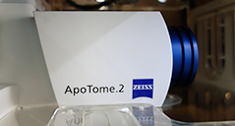  Apotome in light path |  | 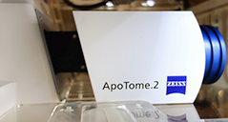  One click to right  Apotome out of light path
- Make sure the correct stage plate for holding your samples is installed.
If it is not,
- Switch to 10X Lens
- Lower focus
- Remove old stage
- Insert new stage plate, one corner declined at an angle to push in springs in stage
- Snap in flat – critical that the insert is flat
- If taking pictures using transmitted light, align for Köhler illumination.

Lenses
All samples must be coverslipped with #1.5 coverslip. See http://microscopynotes.com/coverslips/
You may get images with plastic coverslips or #0 or #1 glass, but the images are ideal with #1.5. If you have samples that cannot be coverslipped, talk to staff before trying to image.
You may go back and forth from the 5X, 10X, 20X, and 40X air lenses with no limitations. Use the touchpad to go from one lens to the next. They are set approximately parfocal.
If you use the 40X or 63X oil lenses, you may not go back to the 20X or 40X air lens. If oil gets on the 20X or 40X air lens or you cannot get a good image with these lenses, contact staff immediately for cleaning.
You may use the 5X or 10X lens for locating samples and go back and forth with the oil lenses.

Software operation
At the top left of Zen, there are tabs labeled “Locate”, “Acquisition”, “Processing”, “Maintain”.
Locate is only for looking by eye through the eyepieces. There are buttons for selecting which light mode you want to look by. You may also use the microscope touch pad to select which imaging mode you would like.
DO NOT change settings in the lightpath window in the “Locate” tab.
DO NOT use the “Live” button and other camera buttons in the “Locate” tab. All camera imaging must be done in the Acquisition tab.
The Acquisition tab will be discussed below. This is where you take pictures and may change the lightpath settings.

Standard Histology, Brightfield, Nomarski, DIC, Phase Contrast, Crossed Polarization
Set up Köhler illumination.
For Nomarki/DIC, the polarizing filter in the condenser should be set to the left. For other Polarizing techniques, it may be rotated. For Brightfield, you may remove the filter entirely.
Put sample on microscope stage
  - Using the touch pad turn on TL or use the computer "Locate" tab and click on Brightfield, DIC, or Phase.
  - Adjust light on front bottom of microscope
  - Open iris diaphragm
  - Focus on sample. Don’t worry if lighting is uneven, at this point sample must be in focus
  - Close field diaphragm
  - Using knobs next to condenser to move it up and down, focus light to a small bright spot
It should appear to be an octagon with sharp edges.
  - Using small metal knobs on front of condenser, center small bright spot.
  - Open field diaphragm slowly to edge of field of view. Do not open all the way!
  - Later, in the acquisition tab, you may want to adjust the size of the iris diaphragm. In general, it should be open all the way, at 0.55.
For more details, see this webpage http://microscopynotes.com/koehler/.

Acquisition
After you have located your sample in focus and adjusted for Kohler illumination if using a brightfield technique, you are ready to collect images using the Acquisition tab.
Settings are defined in three windows:
Acquire
Channels
Lightpath
Channels window assigns a different lightpath for each picture you want to take. For instance, if you have Brightfield, Alexa 488, and Cy5 listed, when you click on one of these, it will be shown when you hit the live button.
There are checkboxes to the left of each channel.
When you click the Snap or Start Experiment button, the checked channels will be imaged.
Workflow:
- Set up the light intensity, exposure time, and other settings for each channel using the live button. Display look up table at full range. Maximum intensity anywhere in range 4000 to 14000. For fluorescent samples, set the intensity based on the brightest condition. DO NOT SATURATE. Click the Range Indicator button to make sure you are not saturating.
- Right click on one channel to define it as the focus reference. This is the channel you will focus on manually
- If tiling or Z, use one channel to set up the experiment parameters.
- Click Snap or Start Experiment button to take pictures to be saved.
Easiest way to load settings:
Open an image from an earlier session that worked well.
Click on Acquisition tab; this will not work in Locate menu.
Click "Reuse" button to load settings.
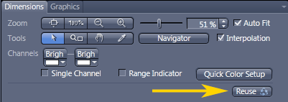
DO NOT use settings in the Experiment Manager pull down menu. Most of these are corrupted and cannot be stabilized.
You can also add channels by clicking “+” in the channels window.
We have noticed that users are setting up their own imaging methods and using the wrong camera. We highly recommend asking for staff assistance when setting up new methods. However, if you are setting up your own methods, note the following.
This microscope has two cameras.
When you set up a new channel, you need to make sure you are using the correct camera and the correct microscope port.
ALL FLUORESCENCE SHOULD USE THE MONOCHROME CAMERA AND THE LEFT SIDE PORT.
Color brightfield and color Nomarksi/DIC are the only imaging modes we recommend with the color camera.
All fluorescence, phase contrast, and non-chromogenic Nomarski should be done with the monochrome camera.
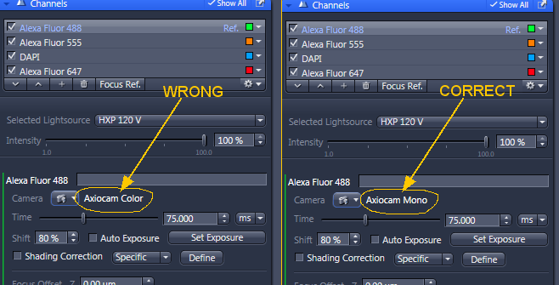
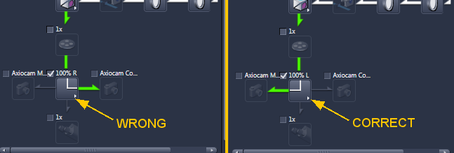
IF YOU HAVE ANY QUESTIONS ABOUT CHANNELS SETTINGS, PLEASE ASK STAFF

This document does not discuss the details of the lightpath window at the left.
Warning: Altering these settings can be tricky. Ask staff for help if shutters are not opening and closing properly. If you click around in this window, channels will need to be redefined.
If you want to be expert in this, we can teach you, but most users do not need to touch these settings and there are too many options to write about here.

Acquire window has the camera settings. Most people will take images with
- Gain set to 3
- Binning 1
- Full chip size, 1920 x 1460
Because of the environmental chamber, the color camera has to be mounted vertically. For stage tiling, the software setting must be set to 90 degrees CCW. The Mono camera should have software rotation set at 180 degrees.
If you do not like vertical images, please set the image area to be a square. If you change the angle of the camera in software, the joystick for moving the field of view will be rotated compared to what you see on the screen.
The default setting for the color camera is 90 degrees CCW. If you change this, you must change it back at the end of your session.

Saving Files
Store files on Drive D: or directly to your shared server space.
DO NOT STORE FILES ON DESKTOP or anywhere on Drive C: including "Pictures" folder.
Files left on the Desktop or Drive C: may be deleted without warning.
For simple snapshots, you may want to set up autosave to save in both Zeiss native format and export as TIF.
Do not save as jpeg!
Make sure you update the file name each time you switch to a different sample!
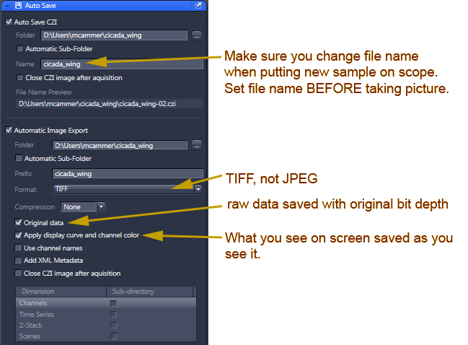
(Additional instructions online for using the Processing Tab for alternative export methods, especially useful after stitching.)
Warning: Autosave and Processing tab outputs default to My Pictures. Make sure you set Drive D: as the output.
* Filling Drive C: will crash the system.
* Files left on the Desktop or Drive C: may be deleted without warning.

Why save files twice?
For fluorescent pictures, we recommend only saving files as CZI and processing them in ImageJ.
However, brightfield imaging applies a gamma function which is not saved in the raw CZI format. But exported TIF files lose all other metadata such as spatial information. Thus, the recommendation to save twice. Uncheck “original data” in the export section of the window to save the raw 16 bit data as CZI and what you see on the screen as a standard RGB image. PNG may be used as an alternative to TIF.

Z series
Click the Z Series checkbox in the upper left window. A new Z window will open.
Define the top and bottom positions. Set the Step Size.
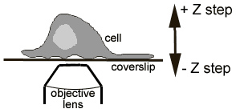
If imaging multichannels, experiment order needs to be set for each channel per Z position for precise registration or each Z first for faster but less spatially precise Z collection.

Tiling
Tiling should be collected with 10% overlap at the edges and be followed by Stitching in the Processing tab with new output and “fuse tiles” checked on.
There are a few ways to define regions to be tiled.
The simplest is to move to the center of a region and set X x Y numbers of images to be collected. Another method is to move around a large area and set stakes.
However, both these methods have limited options for setting precise focus weigh points over not perfectly flat samples.
Detailed instructions for full slide tiling are being written and will be posted soon. They involve collecting a fast scan of a large area (> 1 cm^2 if needed) using 5x or 10x lens, outlining regions, and then setting focus points using a high magnification lens within these regions.
In the Advanced setup you may preview large areas, set focus reference points, and trace irregular regions for tiling.
Incubation - Heater
The incubator may be turned on only from the Zen software.
The incubation control is in a window on the far right of the screen. (There is a little triangle that can open and close this side panel where options windows are hidden.)
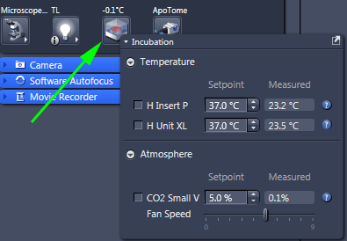
The small touch screen pad on the table does not connect to the incubator!
If using CO2 tank, need to make sure hoses & regulator connected properly. They may be connected to a different stage insert.

