Startup Guide for Evos in ACLSW 421
last updated 20180801
SHUTDOWN
- Bring all focus sliders to lowest position.
- Quit all software.
- All stage plates in plastic box and up on shelf. No loose parts left on table.
- Throw out all Kimwipes etc.
- Turn off scope and cover with white cover.
- End iLab Kiosk session.
- Logout or shutdown computer.
- Don’t forget to take your USB storage device!
STARTUP
- Wake up or turn on computer.
- Put USB key or external HD in slot in front of computer.
(You may also connect to \\research-cifs.nyumc.org\ to transfer files later, but Evos will only allow raw data saving to a USB device.)
- Open browser window, schedule in iLab, start Kiosk
- Turn on microscope, switch right side
- Start Evos Auto software
- Insert correct stage plate into stage of microscope.
All stage plates should be in plastic box and box should always be up on shelf.
Standard configuration is the non-environmental stage. If you change the stage, DO NOT OVERTIGHTEN SCREWS.
- Vertical VESSEL EXPERT button to choose the correct stage type.
You may move stage by dragging the blue dot in the VESSEL EXPERT window, cleft clicking and dragging on the image, or touching the screen on the image and dragging. (This is a touch screen computer.)
- Put your sample(s) on microscope stage. If coverslipped, coverslips go down.
- Select lens. Plastic dishes and flasks may only work with 4X and 10X. They might work with 20X, but don’t count on it.
- For most samples, Phase is the easiest highest contrast way to initially focus. 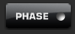 Another favorite for fluorescence Is DAPI
- Click to right of Power label to turn light on off and use slider to increase/decrease light.
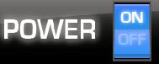
- Drag COARSE focus to bring sample into focus. FINE to get perfect. Hovering the pointer over either pane and moving the mouse ball will adjust focus. This also works hovering over the image.
- Set lighting for each channel you need to image. All fluorescence should be imaged with the Monochrome camera.
If you are comparing different conditions, set for the brightest of the conditions and keep constant for all imaging so relative differences are valid.
- You may want to put black box over samples or turn off overhead light for fluorescence.
- Use SETTINGS tab to select the channels you need imaged when you click CAPTURE ALL.
- Saving brightfield color histology is simple: Save as TIF or PNG. DO NOT USE JPG.
WARNING:
Images may not be saved with proper (or any) scaling information embedded in them.
Always put lens magnification in filename &/or folder name!
- If you simply need a snapshot, save fluorescent images similarly.
However, if you will need to separate the channels or need quantification of intensities, must save Underlying Channels as separate files.
For Tiling / Mosaics, look in Scan tab or read the full manual linked from http://microscopynotes.com/evos/
Hint for saving after tiling: the stitched composite may be rescaled smaller before being automatically saved. This means that if you used a 20X or 40X lens, the resolution is lost. To solve this problem, go to the Export tab and save the image as High resolution TIFF.
Time lapse instructions at http://microscopynotes.com/evos/timelapse.html or look at full Evos manual.
For low light samples or more quantitative work, there is an “Actual Mode”.
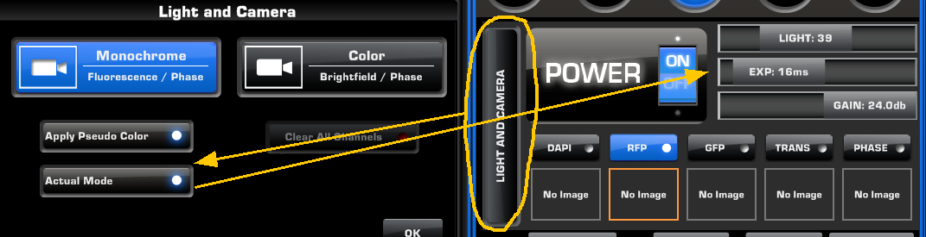
High gain is noisy, but allows for low light and faster exposures. This is especially useful for time lapse experiments where bleaching or photo damage to live cells is problematic.
This window also has the option to turn off pseudo coloring so images are displayed in grayscale.

Additional notes at http://microscopynotes.com/evos/

